­­Frontier Sales Proposal

{{CustomerName}}

Quote Number: {{QuoteNumber}}

**{{QuoteOwner}}**

**{{Designation}}**

**Phone: Mobile: Email:**

### {{Phone}}

{{Mobile}}

[{{Email}}](mailto:test@ftr.com)



#### Frontier Proprietary and Confidential

# Frontier’s contribution to...

**Business Challenges & Objectives**

**Our Solution**

**Your Business Benefits**

**Our Strengths & References**

**Who we are**

Frontier is leading the “un-cable” revolution. Driven by our purpose, Building Gigabit America™, we are relentless in our pursuit of always delivering a better customer experience. Providing digital infrastructure that empowers people to create the future, we’re connecting millions of consumers and businesses in 25 states with reliable fiber internet and multi-gigabit speeds.



“Frontier is Building Gigabit America . We are deploying fiber and connecting people to the digital society at a record pace . Our team’s operational discipline over the last year has

improved Frontier’s financial trajectory and positioned us as the preferred digital partner for customers across our footprint .”

**– Nick Jeffery, President and Chief Executive Officer**

# Our focus, your success

* At Frontier, we believe in the power of technology to change lives. That’s why we take pride in being a trusted business telecommunications partner, helping you meet today’s challenges and technology demands. With more than 180,000 miles of fiber spanning 25 states, our growing network is designed with the evolving needs of business customers like you in mind.
* We know providing better solutions, better service, and better value is the best way to ensure your business wins. From dedicated connectivity to fully managed services, we’re committed to practical and powerful solutions that bring teams together and move businesses forward.

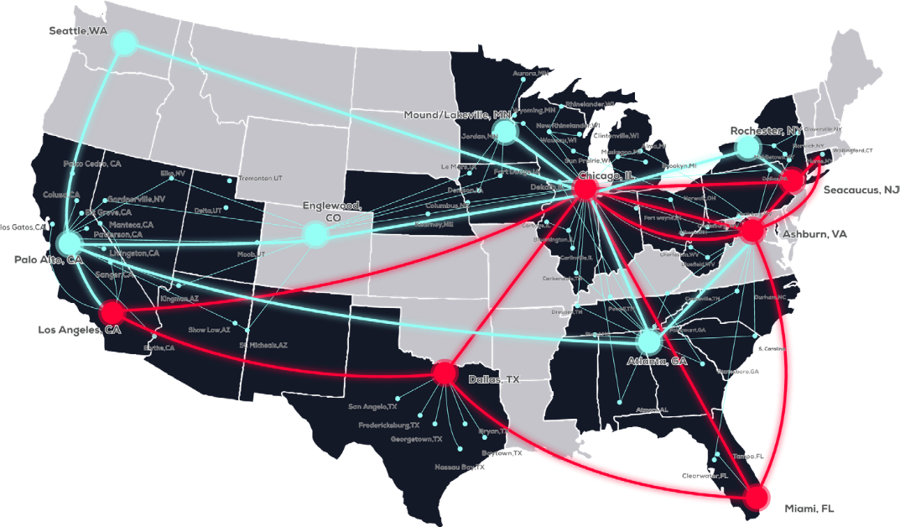

10 Gpbs Core Network

100 Gpbs Core Network

**FTR Covered States**

# Reliable connectivity, on your terms

Self-service when you want to, managed & personalized when you don’t.

# An Advanced Business Solutions Portfolio

##### Built with your needs in mind

* **Robust** solutions portfolio for businesses of any size
* **State of the art offerings** with multiple hosting and service options
* **Fully managed solutions** so you can concentrate on your business’s critical goals
* **Customizable –** True end-to-end solutions

     

##### Strategize

**Deploy**

**Design**

**Manage**

**Integrate**

**Secure**

Unified Communications by Frontier (UCF)

Frontier Direct Calling



Contact Center as a Service (CCaaS)

Managed WLAN

**Managed Network Services (MNS)**

**Managed Dedicated Internet**

SIP Trunking

Managed

Firewall

## Multisite and Ethernet

Managed Wi-Fi (MNS)

Connect Cloud

Managed Security (MNS)

Managed Cellular Failover (MNS)

# Executive Summary

We’re dedicated to understanding your business challenges. As a result, we can custom-tailor a solution that meets your needs and gives you the confidence to move forward.

Our recommendations based on the needs defined above include:

{{#SA}}

Service Term: {{ServTerm}}

Service Location: {{ServiceLocation}}

Total Service Location MRC: {{EachLocationTotalRecurring}}

Total Service Location NRC: {{EachLocationOneTimeCharge}}

|  |  |  |  |  |  |  |  |  |
| --- | --- | --- | --- | --- | --- | --- | --- | --- |
| **Product Name** |  | **Quantity** |  | **Term Length** |  | **NRC** |  | **MRC** |

{{#Line}}

|  |  |  |  |  |  |  |  |  |
| --- | --- | --- | --- | --- | --- | --- | --- | --- |
| **{{ProductName}}**  {{HANDOFF}} {{MINBLOCK}} {{INCLDBOT}} {{^IF_isBundle}}{{SLA}}{{/IF_isBundle}} {{FirewallModel}} {{EVCType}}{{^IF_isBundle}}{{SPEED}}{{/IF_isBundle}} {{IsPartnered}}  {{IPBLOCK}} |  | {{Quantity}} |  | {{ServiceTerm}} |  | {{^IF_isBundle}}{{OneTime}}{{/IF_isBundle}} |  | {{^IF_isBundle}}{{Recurring}}{{/IF_isBundle}} |

{{/Line}}{{/SA}}

|  |  |  |  |  |  |  |  |  |
| --- | --- | --- | --- | --- | --- | --- | --- | --- |
| **Total** |  |  |  |  |  | {{OneTimeTotal}} |  | {{RecurringTotal}} |

The services set forth in this proposal will be provided by Frontier Communications and its affiliates (collectively referred to herein as”Frontier”). Frontier does not consider the proposal itself to be a legally binding offer to contract. Pricing contained within this document is budgetary, and a site survey may be required prior to a final quote. This quote is valid for up to thirty days from the date hereof. Taxes and surcharges are not included.

This proposal is confidential and contains proprietary information. The contents contained here in are not to be shared with parties other than the customer and its employees named in this document is confidential and the property of Frontier Communications Corporation.